VOLUME 3
ROBOTICS DESIGN METHODOLOGY
Design Methodology | Robotics Product Development Process | Mechanical Design Considerations


Module Overview
Building a robot that works once on a lab bench is very different from building one that people can buy, use safely every day and repair. The difference is method: a disciplined way of turning a need into requirements, requirements into ideas, ideas into a tested design, and a design into a product. This module teaches that method for robots, and the core mechanical design skills — sizing motors and gearboxes, choosing materials, checking strength, stiffness and stability — that every robotics engineer needs.
All examples follow one case study: an indoor delivery robot that carries parcels of up to 10 kg along corridors and up small ramps, with a 2-joint arm that presents the parcel to the user. Every formula is explained in plain language, followed by a worked example with real numbers. The labs use free Python tools or a spreadsheet; no workshop is needed. Taught end-to-end, the module is designed to fill approximately 28–32 hours of instruction and practice.
# | Topic | Hands-on Focus
1 | Introduction to Robotics Design Methodology | Map the subsystems of a real robot
2 | Robotics Product Development Process | Lab 1: Requirements and decision matrix
3 | Mechanical Design Considerations | Lab 2: Actuator sizing · Lab 3: Link design and FMEA
4 | Practical Lab Exercises (with model solutions) | Python or spreadsheet calculators
5 | Integrated Mini-Project: Design Review Package | Automated requirement checks
6–7 | Design Pitfalls, Assessment and Revision | Formula sheet, questions, rubric

Learning Outcomes
By the end of this module, learners will be able to:
- Explain why a structured design methodology is needed and describe a robot as a mechatronic system.
- Describe each stage of the robotics product development process, including stage gates, verification and validation.
- Write measurable requirements, decompose functions, generate concepts and select one with a weighted decision matrix.
- Calculate joint torques, gear ratios, tractive force and wheel torque, and select actuators with suitable safety factors.
- Choose materials and check links for stress and deflection; evaluate tip-over stability and power budgets.
- Apply DFM/DFA principles, choose manufacturing processes and assess risk with FMEA and relevant safety standards.
- Assemble the calculations into a design review that checks every requirement.
Hardware and Software Required
Item | Purpose | Free option
PC or laptop | Calculations, CAD, documentation | —
Python 3.10+ with NumPy and Matplotlib, or Google Colab | Lab calculators and plots | Google Colab (browser)
Spreadsheet (LibreOffice Calc, Google Sheets or Excel) | Decision matrix, BOM, FMEA tables | LibreOffice / Google Sheets
3D CAD: Fusion 360, Onshape, SolidWorks or FreeCAD | Model parts and assemblies (optional) | FreeCAD; free education licences
Notebook, ruler, calculator | Sketches and hand checks | —
Optional: digital scale, spring balance, multimeter | Measure mass, force, current on a prototype | —

1. Introduction to Robotics Design Methodology

1.1 What Is a Design Methodology?
A design methodology is a planned sequence of steps, tools and checks that guides a team from a problem to a working, tested product. Without one, teams often jump straight to building, discover late that the robot is too heavy, too slow or too expensive, and have to start again. With one, important decisions are made early, written down, checked by others and tested against clear targets. A methodology does not remove creativity; it makes sure creative ideas are tested before money and time are spent on them.

1.2 The Robot as a Mechatronic System
A robot combines three engineering disciplines (Figure 1.1). The mechanical system provides structure and motion; the electrical system provides power, actuation and sensing; the software and control system provides intelligence. The disciplines are tightly coupled: a heavier frame needs bigger motors, which need a bigger battery, which adds more weight; a flexible arm makes the control software oscillate. Good robot design therefore treats the robot as one system and makes trade-offs across disciplines.
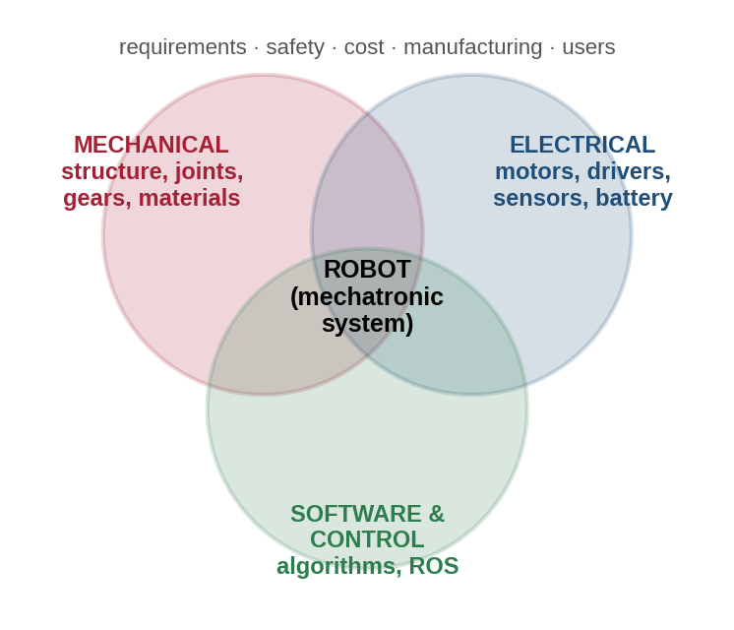
Figure 1.1: A robot is a mechatronic system: mechanical, electrical and software subsystems overlap and must be designed together.

1.3 Systems Thinking and the V-Model
Systems engineering breaks a large problem into smaller subsystems with clear interfaces, then integrates and tests them step by step. The V-model (Figure 1.2) shows this: the left side moves from stakeholder needs down to component design; the bottom is building; the right side moves up again through testing. Every design level on the left has a matching test on the right — component designs are checked by component tests, system requirements by system verification, and stakeholder needs by validation with real users.
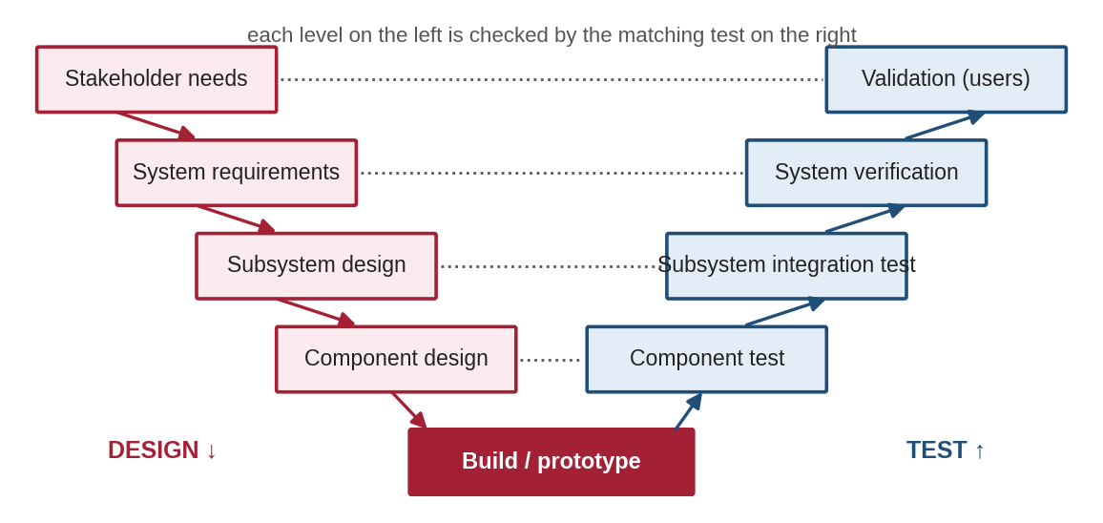
Figure 1.2: The V-model: each design decision on the left is checked by a matching test on the right.

1.4 Linear, Stage-Gate and Agile Approaches
A stage-gate process divides development into stages separated by design reviews (gates) where the team decides to continue, rework or stop. It is common for hardware because physical changes are expensive. Agile methods, popular in software, use short cycles (sprints) that each deliver something testable. Most successful robotics teams mix the two: stage gates for big hardware commitments (tooling, production) and short build-test-learn cycles inside each stage, using cheap prototypes, 3D printing and simulation.

1.5 Documentation and Teamwork
Design work must be traceable: anyone should be able to see why a decision was made. Teams keep a requirements list, a design log or engineering notebook, CAD files and calculations under version control (e.g. Git or the CAD system’s own versioning), a bill of materials (BOM), test reports and minutes of design reviews. Typical review points are a concept review, a preliminary design review (PDR) and a critical design review (CDR) before parts are made.

1.6 Common Mistakes to Avoid
- Starting CAD before the requirements are written and agreed.
- Designing mechanics, electronics and software separately and "integrating at the end".
- Keeping decisions in people’s heads instead of in documents everyone can see.

2. Robotics Product Development Process

2.1 Overview of the Process
Figure 2.1 shows a practical seven-stage process. Each stage ends with a review (gate), and results from later stages often send the team back to earlier ones — iteration is normal and healthy. The rest of this section explains each stage using the delivery-robot case study.
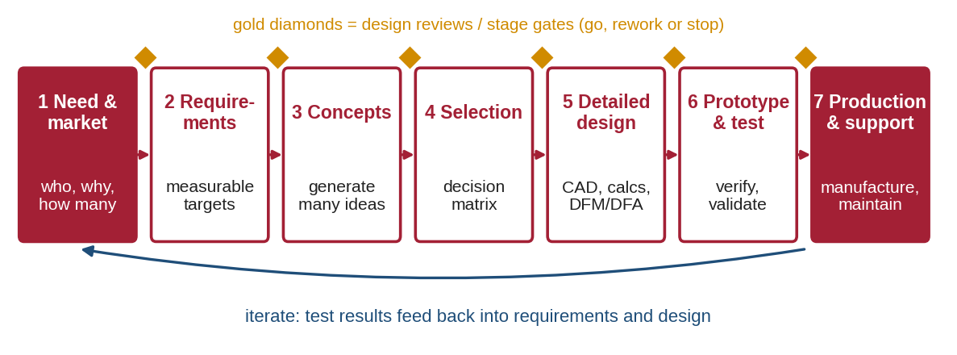
Figure 2.1: The seven-stage robotics product development process with design reviews and feedback loops.

2.2 Stage 1: Need Identification
Every product starts with a need, not a technology. Engineers identify stakeholders (users, buyers, maintenance staff, safety officers), observe how the task is done today, and interview users. For the case study: hospital staff spend hours carrying small parcels between departments; buyers want low cost and reliability; nurses want the robot to be quiet and never block corridors. The result is a short problem statement: "Deliver parcels up to 10 kg between departments of a building, autonomously, safely and quietly."

2.3 Stage 2: Requirements Specification
Needs are turned into requirements: measurable statements of what the robot must do, each with a target and a way to check it. Good requirements are SMART — Specific, Measurable, Achievable, Relevant and Testable. "The robot should be fast" is not testable; "maximum speed ≥ 1.2 m/s on a level floor" is. Requirements are divided into functional (what it does) and non-functional (how well: safety, cost, noise, size) and given a priority (must / should / could).
ID | Requirement | Target | Priority | Verification
R1 | Payload | ≥ 10 kg | Must | Load test
R2 | Maximum speed (level floor) | ≥ 1.2 m/s | Must | Timed run
R3 | Climb a ramp with full payload | 5° slope | Must | Ramp test
R4 | Runtime per charge | ≥ 4 h | Should | Battery test
R5 | Footprint (fits doors and lifts) | ≤ 0.60 × 0.50 m | Must | Measurement
R6 | Stop from full speed | ≤ 0.5 m, without tipping | Must | Braking test
R7 | Noise at 1 m | ≤ 55 dB(A) | Should | Sound meter
R8 | Emergency stop and bumpers | Present and working | Must | Inspection + test
R9 | Bill-of-materials cost | ≤ ₹2,50,000 | Should | BOM review

2.4 Stage 3: Functional Decomposition and Concept Generation
Before choosing parts, break the overall function into sub-functions (Figure 2.2). This keeps the team focused on what must happen rather than how, and opens the door to many solutions.
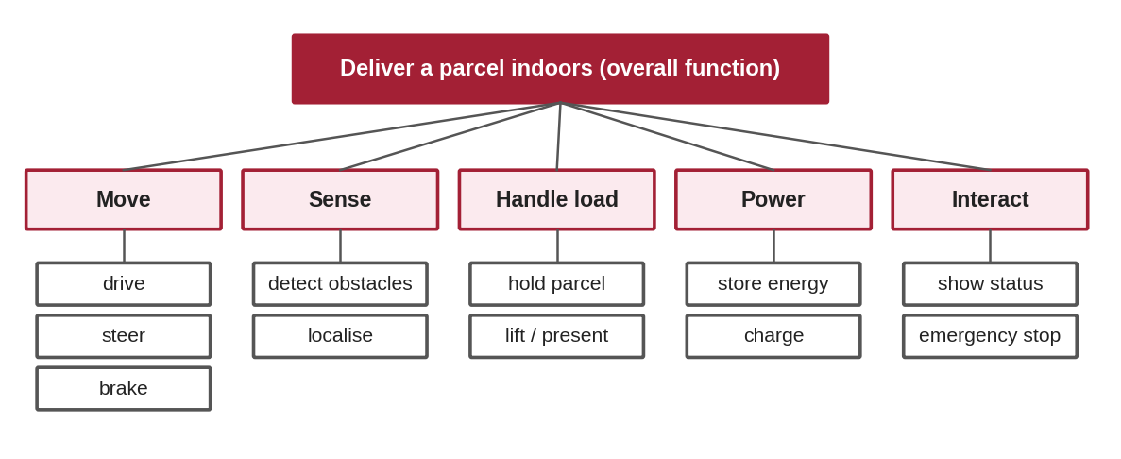
Figure 2.2: Functional decomposition of the delivery robot into sub-functions.
For each sub-function, list several possible solutions in a morphological chart. Combining one option from each row produces a complete concept; different combinations produce very different robots. Brainstorming, sketches, studying existing products (benchmarking) and patents all feed this stage.
Sub-function | Option 1 | Option 2 | Option 3 | Option 4
Drive and steer | Differential + casters | Four-wheel skid steer | Mecanum (omni) | Tracks
Detect obstacles | 2D lidar | Depth camera | Ultrasonic ring | Bumper switches
Hold the parcel | Open tray | Locked box | Lift arm + tray | Conveyor top
Store energy | Li-ion pack | LiFePO₄ pack | Lead-acid | Supercapacitors
Frame | Aluminium extrusion | Bent sheet metal | 3D-printed parts | Welded steel

2.5 Stage 4: Concept Selection
Concepts are compared against the requirements in two steps. A quick Pugh matrix compares each concept with a reference using +, 0 and − for each criterion, to remove weak ideas. A weighted decision matrix then scores the remaining concepts. Each criterion i gets a weight wᵢ (the weights add up to 1), each concept gets a score sᵢ from 1 to 5, and the total is:
Total = Σ wᵢ · sᵢ (maximum 5.0)(2.1)
Worked example 2.1 (drive concept; full calculation in Lab 1). With weights cost 0.25, manoeuvrability 0.20, ramps 0.15, efficiency 0.15, simplicity 0.15 and odometry 0.10, the differential drive scores 0.25 × 5 + 0.20 × 4 + 0.15 × 3 + 0.15 × 5 + 0.15 × 5 + 0.10 × 4 = 4.40, ahead of skid steer (3.45), mecanum (2.85) and tracks (2.75). Always repeat the calculation with different weights (sensitivity analysis): if the winner changes when one weight changes a little, the decision is not robust and needs more information.

2.6 Stage 5: Detailed (Embodiment) Design
The chosen concept is turned into a complete design: CAD models of every part, engineering calculations (motor sizing, stress, stability — Section 3), electrical schematics, software architecture, a BOM with costs and suppliers, and drawings with dimensions and tolerances. Two principles reduce cost and errors:
- Design for Manufacture (DFM): choose shapes and tolerances that the chosen process can make easily (e.g. constant wall thickness for 3D printing, standard bend radii for sheet metal).
- Design for Assembly (DFA): fewer parts, fewer fastener types, self-locating features, parts that cannot be fitted the wrong way, and easy access for maintenance.

2.7 Stage 6: Prototyping, Verification and Validation
Prototypes answer questions quickly and cheaply: a cardboard model tests size, a 3D-printed joint tests motion, a breadboard tests electronics, a simulation tests software. Maturity is often described with the Technology Readiness Level (TRL) scale from 1 (basic idea) to 9 (proven in real operation). Testing has two different purposes:
- Verification — "did we build the robot right?": each requirement is tested with its stated method (e.g. the robot climbs a 5° ramp with 10 kg).
- Validation — "did we build the right robot?": real users try it in the real environment and confirm it solves their problem.

2.8 Risk Management and Safety
Failure Mode and Effects Analysis (FMEA) lists what could go wrong, what effect it would have, and how likely it is to be noticed. Each failure mode is rated from 1 to 10 for Severity (S), Occurrence (O) and Detection (D), where 10 is the worst (most severe, most frequent, hardest to detect), and the Risk Priority Number is:
RPN = S × O × D (1 to 1000)(2.2)
Items with the highest RPN are fixed first — but any item with high severity (9–10) needs action whatever its RPN. Robots that work near people must also follow safety standards. Important ones include ISO 12100 (risk assessment for machinery), ISO 10218-1/-2 (industrial robots), ISO/TS 15066 (collaborative robots), ISO 13482 (personal care and service robots) and IEC 61508 (functional safety of control systems). Products sold in different countries also need the local certification marks.

2.9 Stage 7: Production, Support and Cost
Moving to production means choosing manufacturing processes for the expected volume, setting up suppliers and quality checks, writing manuals and planning spare parts, software updates and end-of-life recycling. Figure 2.3 shows a widely observed trend: most of a product’s lifetime cost is decided by choices made in the early stages, while the cost of changing a design rises steeply the later the change is made. That is why time spent on requirements and concepts pays back many times over.
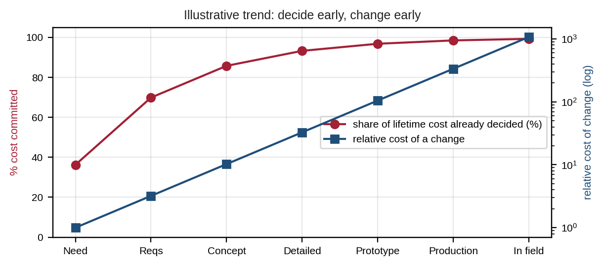
Figure 2.3: Illustrative trend of committed cost and cost of change across the development stages.

2.10 Common Mistakes to Avoid
- Writing requirements that cannot be tested ("robust", "user-friendly") without numbers.
- Falling in love with the first concept and skipping concept selection.
- Treating verification as validation — passing all lab tests does not prove users want the product.
- Doing FMEA after the design is frozen, when changes are expensive.

3. Mechanical Design Considerations

3.1 Loads, Safety Factors and the Design Loop
Mechanical design starts by listing every load the robot will see: weights (its own and the payload), forces from acceleration and braking, slopes, impacts, vibration and maintenance handling. Calculated loads are multiplied by a safety factor (SF) — typically 1.5–2 for motors and 2–4 for structures — to cover unknown loads, manufacturing variation and wear. Mechanical design is a loop: mass estimates set motor sizes, motors add mass, and the loop is repeated until the numbers settle.

3.2 Joint Torque of a Robot Arm
A motor must hold the arm against gravity. The torque at a joint equals the sum of each weight multiplied by its horizontal distance from the joint. The worst case is usually when the arm is horizontal (Figure 3.1). For the case-study arm (link 1: 0.30 m, 0.40 kg; link 2: 0.25 m, 0.30 kg; elbow motor 0.25 kg; payload 0.50 kg; link masses act at their midpoints):
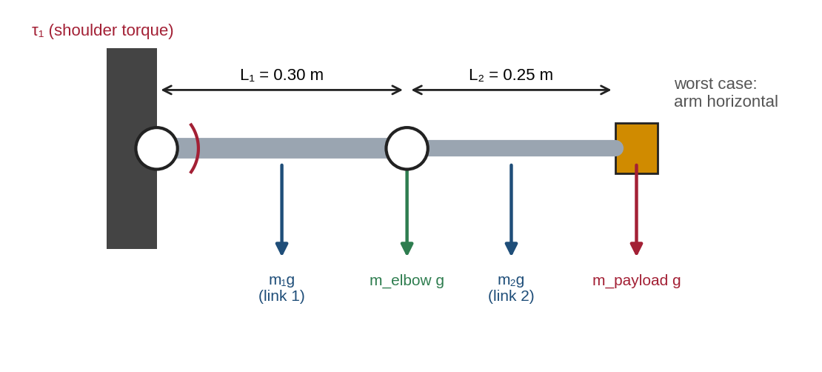
Figure 3.1: Gravity loads on a 2-link arm in its worst-case horizontal position.
τ₁ = g [m₁L₁/2 + m_elbow L₁ + m₂(L₁ + L₂/2) + m_payload(L₁ + L₂)](3.1)
Worked example 3.1. τ₁ = 9.81 × [0.40 × 0.15 + 0.25 × 0.30 + 0.30 × 0.425 + 0.50 × 0.55] = 9.81 × 0.5375 = 5.27 N·m. The elbow carries only link 2 and the payload: τ₂ = 9.81 × [0.30 × 0.125 + 0.50 × 0.25] = 1.59 N·m. To accelerate the arm, add τ = I·α, where I is the moment of inertia about the joint; for this arm I ≈ 0.24 kg·m², so α = 3 rad/s² needs another 0.73 N·m. With SF = 1.5, the shoulder needs 1.5 × (5.27 + 0.73) = 9.0 N·m (Lab 2). Notice that the payload at the end of the arm causes more than half of the shoulder torque: keep heavy parts close to the joints.

3.3 Choosing Actuators
Actuator | Strengths | Limitations | Typical robot use
Brushed DC + gearbox | Cheap, simple driver | Brush wear, lower efficiency | Small mobile robots, toys
Brushless DC (BLDC) | Efficient, long life, high power density | Needs electronic commutation | Drive wheels, arms, drones, legged robots
Stepper motor | Precise open-loop positioning | Can lose steps; weak at speed | 3D printers, gantries, light axes
Hobby servo | Position control built in, cheap | Limited torque, range, feedback | Prototypes, small arms, education
Smart servo / actuator module | Feedback, networking, compact | Higher cost | Humanoids, research arms

Every motor has a speed–torque curve (Figure 3.2): speed falls as load torque rises, from the no-load speed to the stall torque. Motors can run continuously only at low torque without overheating; peaks are allowed for short times. Select the motor so that the required torque falls inside the continuous region, at the required speed.
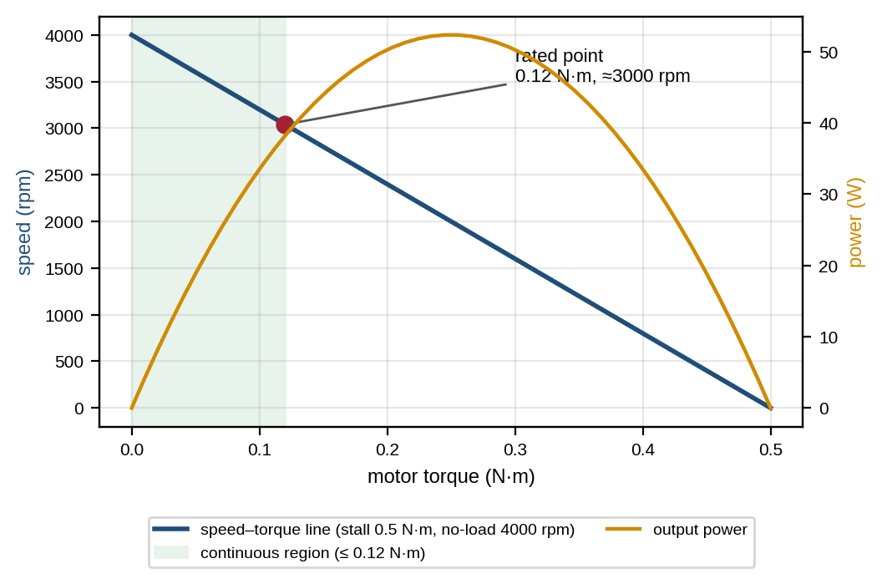
Figure 3.2: Typical DC motor speed–torque and power curves with the continuous operating region.

3.4 Gearboxes and Transmissions
Motors run fast with low torque; joints need slow speed with high torque. A gearbox with ratio N trades speed for torque, with efficiency η:
τ_out = N · η · τ_motor, n_out = n_motor ÷ N(3.2)
Worked example 3.2. The shoulder must turn at 30 rpm. A motor rated 0.12 N·m at 3000 rpm needs N = 3000 ÷ 30 = 100. With η = 0.70, the output is 100 × 0.70 × 0.12 = 8.4 N·m — less than the 9.0 N·m required. Options: a slightly stronger motor (0.13 N·m gives 9.1 N·m), or N = 108 (9.07 N·m but only 27.8 rpm). Small shortfalls like this are common and are exactly what the calculation is for.
Transmission | Typical ratio | Backlash | Efficiency (approx.) | Notes
Spur gear stage | 1–6 per stage | Moderate | 95–98 % per stage | Simple, cheap
Planetary | 3–10 per stage | Low–moderate | 90–97 % per stage | Compact, high torque
Worm | 5–100 | Moderate | 40–85 % | Often self-locking (holds load)
Harmonic (strain wave) | 30–320 | Near zero | 60–90 % | Precise robot joints
Cycloidal | 10–100+ | Very low | 75–90 % | Robust, shock tolerant
Belt / pulley | 1–5 | Low | ≈ 95 % | Moves motor mass away from joint
Lead / ball screw | rotation → linear | Low (ball) | 30–90 % | F = 2π η τ ÷ p (p = lead)

For example, a lead screw with lead p = 8 mm, η = 0.35 and motor torque 0.2 N·m pushes with F = 2π × 0.35 × 0.2 ÷ 0.008 ≈ 55 N.

3.5 Sizing the Drive of a Mobile Robot
The wheels must provide enough tractive force F to accelerate the robot, climb the steepest slope and overcome rolling resistance (Figure 3.3). For mass m, acceleration a, slope φ and rolling-resistance coefficient C_rr:
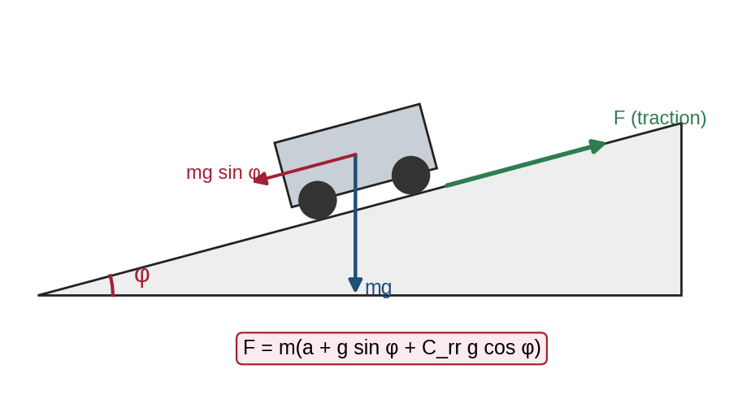
Figure 3.3: Forces on a mobile robot climbing a slope (angle exaggerated).
F = m (a + g sin φ + C_rr g cos φ), τ_wheel = F · r ÷ (number of driven wheels)(3.3)
Worked example 3.3. m = 30 kg (robot + payload), a = 0.5 m/s², φ = 5°, C_rr = 0.015, wheel radius r = 0.075 m, two driven wheels: F = 30 × (0.5 + 0.855 + 0.147) = 45.0 N; τ per wheel = 45.0 × 0.075 ÷ 2 = 1.69 N·m (2.53 N·m with SF 1.5). At 1.2 m/s each wheel turns at v ÷ r = 16 rad/s = 153 rpm, and each motor delivers a peak of about (45.0 ÷ 2) × 1.2 = 27 W. Also check that the wheels have enough grip: the friction coefficient times the load on the driven wheels must exceed F, or the wheels will spin.

3.6 Materials
Material | E (GPa) | Yield (MPa) | Density (g/cm³) | Typical robot use
PLA (3D printed) | 3.5 | ≈ 50 | 1.24 | Prototypes, covers, brackets
ABS / Nylon PA12 | 1.7–2.2 | 40–48 | 1.0–1.05 | Tough housings, printed functional parts
Aluminium 6061-T6 | 69 | 276 | 2.70 | Frames, arm links, plates
Structural steel S235 | 200 | 235 | 7.85 | Bases, shafts, heavy frames
Stainless steel 304 | 193 | 215 | 8.0 | Food, medical, wet environments
Carbon-fibre composite | ≈ 70 (varies) | ≈ 600 | 1.6 | Light, stiff links and drones

Values are typical; printed plastics vary a lot with print settings and direction. For moving parts, compare specific stiffness (E/ρ) and specific strength (yield/ρ) rather than raw values (Figure 3.4): aluminium and steel are almost equally stiff per unit mass, which is why aluminium tubes are popular for light robot frames, while carbon fibre is better still but more expensive.
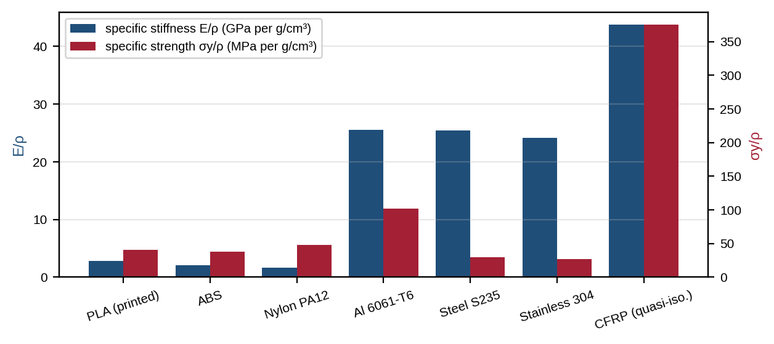
Figure 3.4: Specific stiffness and specific strength of common robot materials.

3.7 Strength and Stiffness of Links
An arm link behaves like a cantilever beam fixed at the joint with a load F at the tip (Figure 3.5). The bending moment is largest at the root, M = F·L. For a section with second moment of area I, outer half-height c and Young’s modulus E:
σ = M·c ÷ I, δ = F·L³ ÷ (3·E·I), SF = σ_yield ÷ σ(3.4)
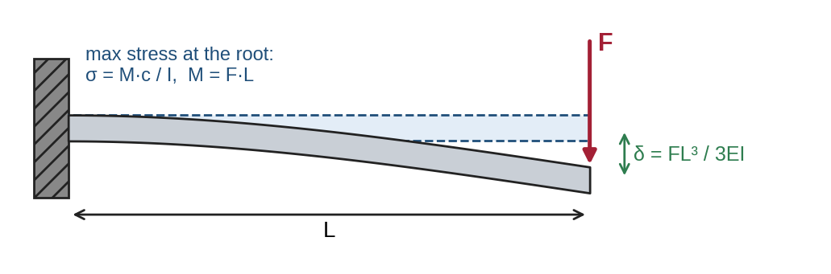
Figure 3.5: Cantilever model of a robot link: root stress and tip deflection.
Worked example 3.4. Link L = 300 mm, tip load F = 15 N, aluminium 6061-T6 square tube 20 × 20 × 2 mm: I = (20⁴ − 16⁴) ÷ 12 = 7872 mm⁴; M = 15 × 300 = 4500 N·mm; σ = 4500 × 10 ÷ 7872 = 5.7 MPa (SF ≈ 48 against yield); δ = 15 × 300³ ÷ (3 × 69,000 × 7872) = 0.25 mm. The stress is tiny but the deflection still matters for accuracy. This is typical in robotics: stiffness, not strength, usually governs link design. Because δ grows with L³, halving a link’s length reduces its deflection eight times.

3.8 Shafts, Bearings, Fasteners and Tolerances
- Support loads with bearings, not motors: motor shafts are designed for torque, not for the bending loads of a wheel or arm. Use two bearings per joint, spaced apart, and pass only torque to the motor through a coupling.
- Fasteners: use thread-locking compound or locking nuts where there is vibration; avoid screwing repeatedly into plastic (use heat-set inserts); standardise on few sizes (e.g. M3 and M5 only).
- Tolerances and fits: specify only the accuracy you need — a bearing seat needs a precise fit, a cover does not. Tight tolerances everywhere make parts expensive.
- Backlash and compliance in joints add up along an arm and reduce end-effector accuracy.

3.9 Manufacturing Processes
Process | Best volume | Tooling cost | Accuracy | Typical parts
FDM 3D printing | 1–100 | None | ± 0.2–0.5 mm | Prototypes, brackets, covers
SLA / SLS 3D printing | 1–500 | None | ± 0.1 mm | Detailed parts, small gears
Laser / waterjet cutting | 1–1000s | None | ± 0.1–0.2 mm | Flat plates, chassis panels
CNC machining | 1–1000s | Low | ± 0.01–0.05 mm | Shafts, bearing housings, precise parts
Sheet-metal bending | 10–10,000s | Low | ± 0.2–0.5 mm | Enclosures, frames
Injection moulding | 1,000s–millions | High (moulds) | ± 0.05–0.1 mm | Covers, housings in production

3.10 Stability, Centre of Mass and Power
A mobile robot tips over when the forces push its centre of mass (CoM) outside the area between its wheels (Figure 3.6). When braking with deceleration a, the robot tips forward if m·a·h > m·g·d, where h is the CoM height and d the horizontal distance from the CoM to the front wheel contact. The maximum safe deceleration is therefore:
a_max = g · d ÷ h(3.5)
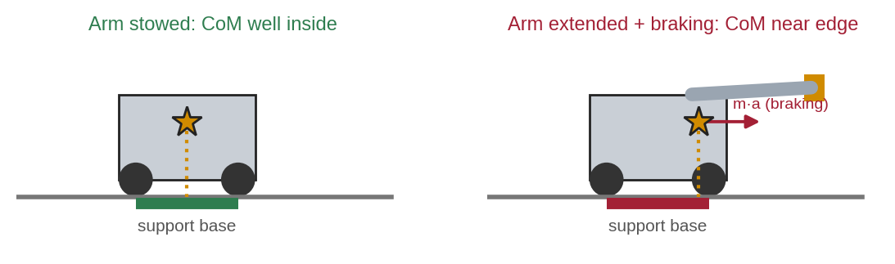
Figure 3.6: Extending the arm and braking move the effective centre of mass towards the edge of the support base.
Worked example 3.5. Requirement R6 asks for a stop within 0.5 m from 1.2 m/s, so a = v² ÷ (2s) = 1.44 ÷ 1.0 = 1.44 m/s². With the arm stowed (d = 0.12 m, h = 0.30 m), a_max = 9.81 × 0.12 ÷ 0.30 = 3.92 m/s² — safe. With the arm extended (d = 0.05 m), a_max = 1.64 m/s² — still safe, but only by about 13 %. Design responses: put the battery low and at the front, limit braking while the arm is extended, or lengthen the wheelbase.
Power budget (worked example 3.6). If the robot needs on average 60 W (drive and electronics) for R4’s 4 hours, it uses 240 Wh. Using only 80 % of a battery’s capacity to protect its life, the battery must store 240 ÷ 0.8 = 300 Wh — for example 24 V × 12.5 Ah. The battery’s mass then goes back into the drive calculation: the design loop again.

3.11 Other Practical Considerations
- Thermal: motors, drivers and batteries need airflow or heat sinks; check temperatures during a long test.
- Environment: dust and water protection is given by the IP rating (e.g. IP54 for dusty, splashed areas).
- Cables: route them away from pinch points and moving joints, with strain relief and enough slack for full motion.
- Maintainability: batteries, wheels and fuses should be replaceable in minutes with common tools.
- Human safety: no sharp edges, guarded pinch points, an easy-to-reach emergency stop and bumpers.
- Tools: 3D CAD (Fusion 360, SolidWorks, Onshape, FreeCAD) for geometry, mass and interference checks; FEA (finite element analysis) to check complex parts after the hand calculation.

3.12 Common Mistakes to Avoid
- Sizing motors for holding torque only and forgetting acceleration and safety factors.
- Hanging wheels or arms directly on motor shafts without bearings.
- Mixing units (mm with m, N·mm with N·m, rpm with rad/s) in one calculation.
- Checking strength but not deflection, or checking parts but not the CoM of the whole robot.

4. Practical Lab Exercises
The labs turn the methods of Sections 2 and 3 into reusable calculators. Each one runs in Google Colab (free, nothing to install) or local Python; Lab 1 can also be done in a spreadsheet. Each lab ends with a model solution. All outputs shown were produced by running the programs.
Lab | Title | Sections | Time
1 | Requirements and weighted decision matrix | 2.3–2.5 | 2.5 h
2 | Actuator sizing for an arm and a mobile robot | 3.1–3.5 | 3 h
3 | Link material selection and FMEA | 2.8, 3.6–3.7 | 3 h

Lab Exercise 1: Requirements and Weighted Decision Matrix
Estimated time | Prerequisites
2.5 hours | Sections 2.2–2.5; basic spreadsheet or Python

Objective
To write SMART requirements for the delivery robot and to choose its drive concept with a weighted decision matrix, including a sensitivity check.
Working Principle
Each criterion has a weight (all weights add up to 1) and each concept a score from 1 to 5. The program multiplies and adds them (equation 2.1), ranks the concepts, then raises the weight of manoeuvrability to 0.40 and re-normalises the weights to see whether the ranking changes.
Procedure
- Rewrite these vague needs as SMART requirements with a target and a verification method: "carry heavy parcels", "long battery life", "safe near people".
- Check the scores in the program against your own judgement and note any you disagree with.
- Run the program (or build the same table in a spreadsheet with =SUMPRODUCT(weights, scores)).
- Record the totals for the baseline and the sensitivity case.
- Find the smallest manoeuvrability weight at which mecanum would overtake skid steer.
Program Code
# Lab 1: weighted decision matrix for the drive concept of an indoor delivery robot
import numpy as np
import matplotlib.pyplot as plt

criteria = ["Cost", "Manoeuvrability", "Ramps/thresholds", "Energy efficiency", "Simplicity/reliability", "Odometry accuracy"]
weights = np.array([0.25, 0.20, 0.15, 0.15, 0.15, 0.10]) # must add up to 1.0
concepts = { # scores 1 (poor) .. 5 (excellent)
"A Differential + casters": [5, 4, 3, 5, 5, 4],
"B Four-wheel skid steer": [4, 3, 4, 3, 4, 2],
"C Mecanum (omni)": [2, 5, 2, 3, 2, 3],
"D Tracked": [3, 2, 5, 2, 3, 1],
}
assert abs(weights.sum() - 1.0) < 1e-9, "weights must sum to 1"

def rank(w):
totals = {name: float(np.dot(w, s)) for name, s in concepts.items()}
return dict(sorted(totals.items(), key=lambda kv: -kv[1]))

base = rank(weights)
print("Weighted totals (max 5.00):")
for name, t in base.items():
print(f" {name:28s} {t:.2f}")

# Sensitivity: what if manoeuvrability matters much more (weight 0.40)?
w2 = weights.copy(); w2[1] = 0.40; w2 = w2 / w2.sum()
print("With manoeuvrability weight raised to 0.40 (re-normalised):")
for name, t in rank(w2).items():
print(f" {name:28s} {t:.2f}")

fig, ax = plt.subplots(figsize=(7, 3.2))
names = list(concepts)
ax.bar(np.arange(4) - 0.2, [base[n] for n in names], 0.4, label="baseline weights")
ax.bar(np.arange(4) + 0.2, [rank(w2)[n] for n in names], 0.4, label="manoeuvrability = 0.40")
ax.set_xticks(range(4)); ax.set_xticklabels([n.split(" ", 1)[1] for n in names], fontsize=8)
ax.set_ylabel("weighted score (max 5)"); ax.set_ylim(0, 5); ax.legend(fontsize=8); ax.grid(axis="y", alpha=0.3)
plt.tight_layout(); plt.savefig("lab1_output.png", dpi=150); plt.show()

Expected Output
Weighted totals (max 5.00):
A Differential + casters 4.40
B Four-wheel skid steer 3.45
C Mecanum (omni) 2.85
D Tracked 2.75
With manoeuvrability weight raised to 0.40 (re-normalised):
A Differential + casters 4.33
B Four-wheel skid steer 3.37
C Mecanum (omni) 3.21
D Tracked 2.62

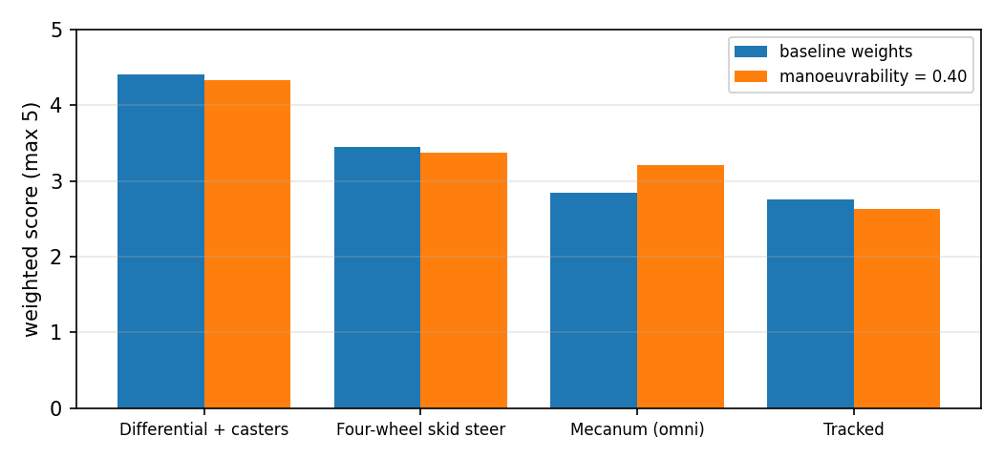
Figure 4.1: Output of Lab 1: weighted scores of the four drive concepts for two weightings.
Observation
# | What to observe | Your observation
1 | Your three SMART requirements
2 | Baseline totals and ranking
3 | Totals with manoeuvrability = 0.40
4 | Weight at which mecanum overtakes skid steer

Model Solution
# | Correct result | Explanation
1 | e.g. "Payload ≥ 10 kg (load test)"; "Runtime ≥ 4 h at 1 m/s average (battery test)"; "Stops within 0.5 m from 1.2 m/s and has a reachable E-stop (braking test, inspection)" | Each has a number and a test
2 | A 4.40 > B 3.45 > C 2.85 > D 2.75 | Differential drive wins on cost, efficiency and simplicity
3 | A 4.33 > B 3.37 > C 3.21 > D 2.62 | Ranking of A is robust; C gains most
4 | 0.50 (before re-normalising) | Found by raising the weight in steps of 0.01 and re-running the ranking

Conclusion
A decision matrix makes reasoning visible and comparable; the sensitivity check shows that the differential drive is the robust choice for this robot. Evidence: requirement list, table or code output, chart and a short justification.

Lab Exercise 2: Actuator Sizing for an Arm and a Mobile Robot
Estimated time | Prerequisites
3 hours | Sections 3.1–3.5; Lab 1

Objective
To calculate the static and dynamic torque of the arm’s shoulder joint, check a motor-gearbox choice, and size the drive motors of the mobile base.
Working Principle
Part A applies equation 3.1 for the static torque, adds I·α for acceleration and multiplies by the safety factor, then compares the gearbox output (3.2) with the requirement. Part B applies equation 3.3 for tractive force, wheel torque, wheel speed and power. A plot shows how the shoulder torque varies with arm angle.
Procedure
- Calculate τ₁ and τ₂ by hand (Worked example 3.1) before running the code.
- Run the program and copy all printed values.
- The gearbox check prints TOO SMALL. Propose two different fixes and verify them by editing the code.
- Change the payload to 1.0 kg and record the new required shoulder torque.
- Change the ramp to 8° and record the new wheel torque.
Program Code
# Lab 2: actuator sizing - shoulder/elbow of a 2-link arm and drive motors of a mobile robot
import numpy as np
import matplotlib.pyplot as plt
g = 9.81

# ---- Part A: 2-link arm, static (holding) torque, worst case = arm horizontal
L1, L2 = 0.30, 0.25 # link lengths (m)
m1, m2 = 0.40, 0.30 # link masses (kg), centre of mass at mid-length
m_elbow, m_pay = 0.25, 0.50 # elbow motor mass at joint 2, payload at the tip (kg)

def shoulder_torque(theta): # theta = shoulder angle from horizontal (rad), elbow straight
arm = m1*L1/2 + m_elbow*L1 + m2*(L1 + L2/2) + m_pay*(L1 + L2) # kg*m
return g*arm*np.cos(theta)

tau1 = shoulder_torque(0.0)
tau2 = g*(m2*L2/2 + m_pay*L2)
# dynamic part: shoulder inertia (point masses + slender rods about their ends)
I1 = m1*L1**2/3 + m_elbow*L1**2 + m2*(L2**2/12 + (L1 + L2/2)**2) + m_pay*(L1 + L2)**2
alpha = 3.0 # required angular acceleration (rad/s^2)
SF = 1.5
tau1_req = SF*(tau1 + I1*alpha)
print(f"Shoulder static torque = {tau1:.3f} N.m")
print(f"Elbow static torque = {tau2:.3f} N.m")
print(f"Shoulder inertia I1 = {I1:.4f} kg.m^2, dynamic torque = {I1*alpha:.3f} N.m")
print(f"Shoulder required torque (SF {SF}) = {tau1_req:.2f} N.m")

# gearbox: motor 0.12 N.m continuous at 3000 rpm, joint must turn at 30 rpm, efficiency 70 %
N = 3000/30; eta = 0.70
print(f"Gear ratio N = {N:.0f}, output torque = {0.12*N*eta:.2f} N.m "
f"-> {'OK' if 0.12*N*eta >= tau1_req else 'TOO SMALL'}")

# ---- Part B: mobile robot drive motors
m, r, a, slope, crr, v = 30.0, 0.075, 0.5, np.radians(5), 0.015, 1.2
F = m*(a + g*np.sin(slope) + crr*g*np.cos(slope)) # total tractive force (N)
tau_wheel = F*r/2 # two driven wheels
rpm = v/r*60/(2*np.pi)
P_wheel = F/2*v
print(f"Tractive force = {F:.1f} N, torque per wheel = {tau_wheel:.3f} N.m "
f"(with SF 1.5: {1.5*tau_wheel:.2f} N.m)")
print(f"Wheel speed = {rpm:.0f} rpm, peak power per wheel = {P_wheel:.1f} W")

th = np.linspace(-np.pi/2, np.pi/2, 181)
plt.figure(figsize=(6, 3)); plt.plot(np.degrees(th), shoulder_torque(th))
plt.axhline(tau1_req, color="r", ls="--", label=f"required with SF and dynamics ({tau1_req:.1f} N.m)")
plt.xlabel("shoulder angle from horizontal (deg)"); plt.ylabel("static torque (N.m)")
plt.grid(alpha=0.3); plt.legend(fontsize=8); plt.tight_layout(); plt.savefig("lab2_output.png", dpi=150); plt.show()

Expected Output
Shoulder static torque = 5.273 N.m
Elbow static torque = 1.594 N.m
Shoulder inertia I1 = 0.2415 kg.m^2, dynamic torque = 0.725 N.m
Shoulder required torque (SF 1.5) = 9.00 N.m
Gear ratio N = 100, output torque = 8.40 N.m -> TOO SMALL
Tractive force = 45.0 N, torque per wheel = 1.689 N.m (with SF 1.5: 2.53 N.m)
Wheel speed = 153 rpm, peak power per wheel = 27.0 W

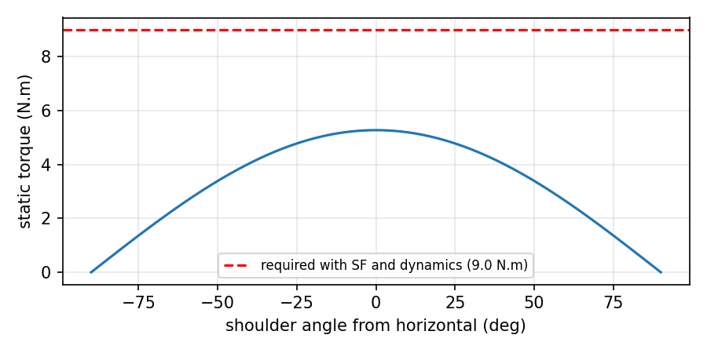
Figure 4.2: Output of Lab 2: static shoulder torque against arm angle compared with the required torque.
Observation
# | What to observe | Your observation
1 | Hand-calculated τ₁ and τ₂
2 | Printed results (all lines)
3 | Two fixes for the gearbox and their output torque/speed
4 | Required shoulder torque with 1.0 kg payload
5 | Wheel torque per wheel on an 8° ramp

Model Solution
# | Correct result | Explanation
1 | τ₁ = 5.27 N·m, τ₂ = 1.59 N·m | Worked example 3.1
2 | As in the expected output | —
3 | (a) motor 0.13 N·m, N = 100 → 9.10 N·m at 30 rpm; (b) N = 108 → 9.07 N·m at 27.8 rpm | (a) keeps speed; (b) keeps motor but is slightly slower
4 | ≈ 13.72 N·m | Static 7.97 N·m + dynamic 1.18 N·m, × 1.5
5 | ≈ 2.26 N·m (3.39 N·m with SF) | F = 30(0.5 + 1.365 + 0.146) = 60.3 N

Conclusion
A few lines of physics turn requirements into motor specifications and reveal undersized parts before they are bought. Evidence: hand calculations, outputs, plot and the justified gearbox fix.

Lab Exercise 3: Link Material Selection and FMEA
Estimated time | Prerequisites
3 hours | Sections 2.8, 3.6 and 3.7; Lab 2

Objective
To compare four materials for the 300 mm arm link by stress, safety factor, deflection and mass, and to rank the robot’s risks with an FMEA.
Working Principle
The program applies equation 3.4 to each option with consistent units (N, mm, MPa), computes mass from cross-section, length and density, then calculates RPN = S × O × D for seven failure modes and sorts them.
Procedure
- Check the Al-tube result by hand (Worked example 3.4).
- Run the program and record the table and the FMEA ranking.
- Choose a material for a link that must deflect ≤ 0.5 mm, be as light as possible and cost little. Justify your choice.
- For the top two FMEA items, propose a design action and re-estimate S, O or D.
- Explain why the tip-over item needs action even though its RPN ranks fifth.
Program Code
# Lab 3: link stiffness/strength/mass for different materials + FMEA risk ranking
import numpy as np
import matplotlib.pyplot as plt

L, F = 300.0, 15.0 # cantilever length (mm) and tip load (N) -> units N, mm, MPa
M = F*L # maximum bending moment at the root (N.mm)

def box(b, t): # square hollow section, outer size b, wall t (mm)
bi = b - 2*t
return (b**4 - bi**4)/12, b**2 - bi**2 # I (mm^4), area (mm^2)

options = [ # name, E (MPa), yield/strength (MPa), density (g/cm^3), section (I, A), outer size (mm)
("PLA solid 20x20 (3D print)", 3500, 50, 1.24, (20**4/12, 400), 20),
("Al 6061-T6 tube 20x20x2", 69000, 276, 2.70, box(20, 2), 20),
("Steel S235 tube 20x20x2", 200000, 235, 7.85, box(20, 2), 20),
("CFRP tube 20x20x2 (quasi-iso.)", 70000, 600, 1.60, box(20, 2), 20),
]
print(f"{'option':32s} {'stress':>7s} {'SF':>6s} {'defl.':>7s} {'mass':>6s}")
rows = []
for name, E, Sy, rho, (I, A), b in options:
sigma = M*(b/2)/I # bending stress (MPa)
delta = F*L**3/(3*E*I) # tip deflection (mm)
mass = A*L*rho/1000 # grams
rows.append((name, sigma, Sy/sigma, delta, mass))
print(f"{name:32s} {sigma:6.2f} {Sy/sigma:6.1f} {delta:6.3f} {mass:5.0f} g")

# FMEA: severity, occurrence, detection (1..10) -> RPN = S x O x D
fmea = [("Lidar misses glass door", 8, 5, 6), ("Pinch point at arm elbow", 8, 3, 7),
("Drive motor overheats on ramp", 7, 4, 5), ("Wheel hub screw loosens", 6, 5, 4),
("Tip-over when braking, arm out", 9, 2, 5), ("Gripper drops payload", 5, 4, 4),
("Battery over-discharge", 6, 3, 3)]
fmea = sorted(((n, s, o, d, s*o*d) for n, s, o, d in fmea), key=lambda r: -r[4])
print("FMEA ranking (RPN = S x O x D):")
for n, s, o, d, rpn in fmea:
print(f" {rpn:4d} S{s} O{o} D{d} {n}")

fig, (a1, a2) = plt.subplots(1, 2, figsize=(10, 3.4))
a1.bar([r[0].split(" ")[0] for r in rows], [r[3] for r in rows], color="tab:blue")
a1.set_ylabel("tip deflection (mm)"); a1.set_title("Deflection of a 300 mm link, 15 N tip load")
for i, r in enumerate(rows): a1.text(i, r[3], f"{r[4]:.0f} g", ha="center", va="bottom", fontsize=8)
a2.barh([f[0] for f in fmea][::-1], [f[4] for f in fmea][::-1], color="tab:red")
a2.set_xlabel("RPN"); a2.set_title("FMEA risk priority"); a2.tick_params(labelsize=7)
plt.tight_layout(); plt.savefig("lab3_output.png", dpi=150); plt.show()

Expected Output
option stress SF defl. mass
PLA solid 20x20 (3D print) 3.38 14.8 2.893 149 g
Al 6061-T6 tube 20x20x2 5.72 48.3 0.249 117 g
Steel S235 tube 20x20x2 5.72 41.1 0.086 339 g
CFRP tube 20x20x2 (quasi-iso.) 5.72 105.0 0.245 69 g
FMEA ranking (RPN = S x O x D):
240 S8 O5 D6 Lidar misses glass door
168 S8 O3 D7 Pinch point at arm elbow
140 S7 O4 D5 Drive motor overheats on ramp
120 S6 O5 D4 Wheel hub screw loosens
90 S9 O2 D5 Tip-over when braking, arm out
80 S5 O4 D4 Gripper drops payload
54 S6 O3 D3 Battery over-discharge

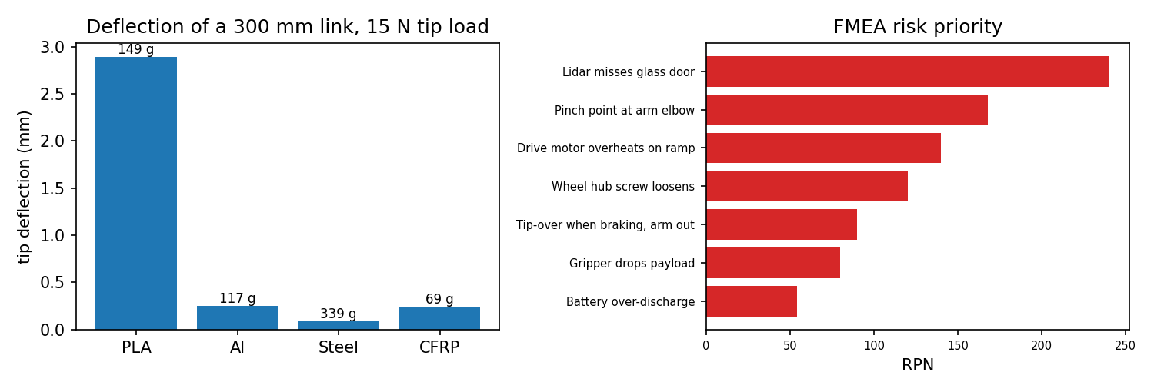
Figure 4.3: Output of Lab 3: link deflection and mass by material (left) and FMEA risk ranking (right).
Observation
# | What to observe | Your observation
1 | Hand-checked Al-tube stress and deflection
2 | Material chosen and justification
3 | Actions and new RPNs for the top two risks
4 | Why the tip-over item needs action

Model Solution
# | Correct result | Explanation
1 | σ = 5.7 MPa, δ = 0.25 mm | Worked example 3.4
2 | Aluminium 6061-T6 tube | Meets 0.5 mm (PLA does not), 117 g, low cost; CFRP is lighter but costlier; steel is too heavy
3 | Glass door: add ultrasonic or bumper sensing → O 5→3, D 6→3, RPN 72. Pinch point: guard or limit torque → S 8→4, RPN 84 | Actions reduce occurrence or improve detection; guarding reduces severity
4 | Severity 9 (injury, damage) | High-severity items need action regardless of RPN; e.g. limit braking with arm out (Section 3.10)

Conclusion
Stiffness drives material choice for robot links, and FMEA turns vague worries into a ranked, actionable list. Evidence: outputs, plot, material justification and updated FMEA.

5. Integrated Mini-Project: Design Review Package

5.1 Problem Statement
Prepare a critical design review (CDR) package for the indoor delivery robot. The package must prove, with numbers, that the chosen design meets every key requirement before parts are ordered. It combines the requirements (Section 2.3), concept choice (Lab 1), motor sizing (Lab 2), link design and FMEA (Lab 3), stability and power checks (Section 3.10), and an automated check script.

5.2 Deliverables and Workflow
- Requirements table with IDs, targets, priorities and verification methods.
- Concept selection record: morphological chart and weighted decision matrix with sensitivity check.
- Layout sketch or CAD showing main dimensions, wheel positions, battery position and estimated CoM.
- Calculations: drive and arm motor sizing, gearbox check, link stress and deflection, tip-over limit and power budget.
- BOM with masses and costs, and an FMEA with actions for the top risks.
- Automated design check (below) showing PASS or FAIL for each requirement, plus a one-page summary of open issues.

5.3 Automated Design Check
Writing the checks as code means they can be re-run instantly whenever a mass, motor or dimension changes — a simple form of the automated verification used in industry.
# Mini-project: automated design check of the indoor delivery robot against its requirements
import math
g = 9.81

def check(rid, name, value, limit, unit, ok):
print(f"{rid:4s} {name:38s} {value:8.2f} {unit:6s} limit {limit:7.2f} {'PASS' if ok else 'FAIL'}")
return ok

results = []
# R3: ramp climbing - drive motor + gearbox must deliver the wheel torque (with SF 1.5)
m, r, a, slope, crr, v = 30.0, 0.075, 0.5, math.radians(5), 0.015, 1.2
F = m*(a + g*math.sin(slope) + crr*g*math.cos(slope))
need_wheel = 1.5*F*r/2
motor_T, motor_rpm, ratio, eta = 0.35, 3000, 10, 0.85 # selected drive motor and gearbox
results.append(check("R3", "wheel torque available vs needed", motor_T*ratio*eta, need_wheel, "N.m", motor_T*ratio*eta >= need_wheel))
results.append(check("R2", "wheel speed available vs needed", motor_rpm/ratio, v/r*60/(2*math.pi), "rpm", motor_rpm/ratio >= v/r*60/(2*math.pi)))
# R6: stop from 1.2 m/s within 0.5 m without tipping (arm extended: CoM 0.05 m behind front contact, 0.30 m high)
decel = v**2/(2*0.5)
a_tip = g*0.05/0.30
results.append(check("R6", "braking deceleration vs tip-over limit", decel, a_tip, "m/s^2", decel < a_tip))
# Arm shoulder joint (from Lab 2): needs 9.00 N.m incl. dynamics and SF 1.5
arm_T = 0.13*100*0.70
results.append(check("A1", "shoulder torque available vs needed", arm_T, 9.00, "N.m", arm_T >= 9.00))
# Arm link stiffness (from Lab 3): Al tube tip deflection must be <= 0.5 mm
results.append(check("A2", "link tip deflection vs allowed", 0.249, 0.5, "mm", 0.249 <= 0.5))
# R4: runtime 4 h at 60 W average, 80 % usable capacity; battery 24 V 15 Ah
need_Wh = 60*4/0.8
results.append(check("R4", "battery energy available vs needed", 24*15, need_Wh, "Wh", 24*15 >= need_Wh))
# R5: footprint must fit 0.60 x 0.50 m
results.append(check("R5", "footprint length (width 0.45 m)", 0.55, 0.60, "m", 0.55 <= 0.60 and 0.45 <= 0.50))
print(f"Overall: {sum(results)}/{len(results)} checks passed")

R3 wheel torque available vs needed 2.98 N.m limit 2.53 PASS
R2 wheel speed available vs needed 300.00 rpm limit 152.79 PASS
R6 braking deceleration vs tip-over limit 1.44 m/s^2 limit 1.64 PASS
A1 shoulder torque available vs needed 9.10 N.m limit 9.00 PASS
A2 link tip deflection vs allowed 0.25 mm limit 0.50 PASS
R4 battery energy available vs needed 360.00 Wh limit 300.00 PASS
R5 footprint length (width 0.45 m) 0.55 m limit 0.60 PASS
Overall: 7/7 checks passed

5.4 Test Cases, Review Questions and Extensions
Test | Change | Expected result
TC1 | Run as given | 7/7 checks pass
TC2 | Arm-extended CoM distance d = 0.04 m | R6 fails (limit 1.31 m/s² < 1.44): stability margin is the weakest point
TC3 | Drive gearbox ratio 7 instead of 10 | R3 fails (2.08 N·m < 2.53 N·m)
TC4 | Battery 24 V × 10 Ah | R4 fails (240 Wh < 300 Wh)
TC5 | Arm motor 0.12 N·m | A1 fails (8.40 N·m < 9.00 N·m) — the Lab 2 finding

Review questions for the CDR panel: Which requirement has the smallest margin, and what happens if the payload grows by 20 %? Which assumptions (C_rr, efficiency, mass estimates) most affect the result? What will be tested first on the prototype? Extensions: add cost and mass totals from the BOM; add a check for motor temperature using duty cycle; or link the script to the CAD model’s mass properties.

6. Design Pitfalls and Troubleshooting
Symptom in prototype | Likely design cause | Fix
Arm sags or cannot lift payload | Torque sized without dynamics/SF; heavy parts far out | Recalculate with I·α and SF; move motors towards the base; use belts
Robot drifts or wobbles | Wheel misalignment, flexible frame, backlash | Stiffer frame, alignment jigs, low-backlash gearbox
Wheels spin on ramp | Too little load on driven wheels or low friction | Move CoM over drive wheels; softer tyres
Motor overheats | Operating outside continuous region | Bigger motor or higher gear ratio; check duty cycle
Screws loosen | Vibration, plastic threads | Thread-locker, locking nuts, heat-set inserts
Robot tips when stopping | High or rear CoM, short wheelbase | Lower battery, longer wheelbase, limit deceleration
Parts do not fit | Tolerances not specified or too tight | Specify fits only where needed; test-print critical features
Over budget late in project | Cost not tracked from concept stage | Maintain a costed BOM from day one; review at each gate

7. Assessment and Revision

7.1 Formula Sheet
Quantity | Formula
Weighted decision score | Total = Σ wᵢ sᵢ (Σ wᵢ = 1)
FMEA risk priority number | RPN = S × O × D
Static joint torque | τ = g Σ mᵢ xᵢ (xᵢ = horizontal distance to joint)
Dynamic torque, design torque | τ_dyn = I α; τ_design = SF (τ_static + τ_dyn)
Gearbox | τ_out = N η τ_motor; n_out = n_motor ÷ N
Tractive force | F = m(a + g sin φ + C_rr g cos φ); τ_wheel = F r ÷ n_wheels
Cantilever link | σ = F L c ÷ I; δ = F L³ ÷ (3 E I); SF = σ_y ÷ σ
Tip-over and braking | a_max = g d ÷ h; a = v² ÷ (2 s)
Battery energy | E = P_avg × t ÷ usable fraction

7.2 Short Conceptual Questions
- Why should requirements be written before any CAD work begins?
- Explain the difference between verification and validation with one example each.
- What is the purpose of a stage gate or design review?
- Why is a sensitivity analysis needed after a weighted decision matrix?
- Why does stiffness, rather than strength, usually govern robot link design?
- Why should a wheel or arm be supported by bearings rather than directly by the motor shaft?
- Give two ways to increase the maximum braking deceleration before tip-over.
- Why can a failure with a low RPN still require urgent action?
Answer key (brief): 1 — requirements define what to design and how to test it. 2 — verification: ramp test meets R3; validation: nurses use it on a ward. 3 — decide go/rework/stop before committing more money. 4 — to see whether small weight changes alter the winner. 5 — deflection limits accuracy long before stress reaches yield. 6 — motor shafts are not designed for bending loads. 7 — lower the CoM; increase d (longer wheelbase, battery forward). 8 — high severity (injury) needs action regardless of RPN.

7.3 Numerical Problems with Worked Solutions
Problem 1. A 0.8 m single link of mass 1.2 kg (CoM at mid-length) holds 2 kg at its tip. Find the holding torque when horizontal. Solution: τ = 9.81 × (1.2 × 0.4 + 2 × 0.8) = 9.81 × 2.08 = 20.4 N·m.
Problem 2. A motor gives 0.5 N·m at 2400 rpm through a 60:1 planetary gearbox with η = 0.85. Find output torque and speed. Solution: τ = 60 × 0.85 × 0.5 = 25.5 N·m; n = 2400 ÷ 60 = 40 rpm.
Problem 3. A 50 kg robot with four driven wheels of radius 0.1 m must climb 10° at 0.3 m/s² (C_rr = 0.02). Find the torque per wheel. Solution: F = 50(0.3 + 9.81 × 0.1736 + 0.02 × 9.81 × 0.9848) = 50(0.3 + 1.703 + 0.193) = 109.8 N; τ = 109.8 × 0.1 ÷ 4 = 2.75 N·m.
Problem 4. An aluminium (E = 69 GPa) tube link with I = 7872 mm⁴ and L = 400 mm carries 15 N at its tip. Find the deflection. Solution: δ = 15 × 400³ ÷ (3 × 69,000 × 7872) = 9.6 × 10⁸ ÷ 1.6295 × 10⁹ = 0.59 mm — (400/300)³ = 2.37 times the 300 mm value.
Problem 5. CoM height 0.4 m, 0.15 m behind the front wheel contact. Maximum braking deceleration? Solution: a_max = 9.81 × 0.15 ÷ 0.4 = 3.68 m/s².
Problem 6. Average power 80 W for 6 h, 80 % usable capacity, 24 V battery. Required capacity? Solution: E = 80 × 6 ÷ 0.8 = 600 Wh → 600 ÷ 24 = 25 Ah.

7.4 Practical Checklist and Rubric
# | The learner can… | Done
1 | Write SMART requirements with verification methods | ☐
2 | Build and interpret a weighted decision matrix with sensitivity (Lab 1) | ☐
3 | Size joint and drive actuators including dynamics and SF (Lab 2) | ☐
4 | Select a link material from stress, deflection and mass; run an FMEA (Lab 3) | ☐
5 | Present a CDR package where every requirement is checked (mini-project) | ☐

Criterion (4 marks each) | Excellent (4) | Good (3–2) | Needs work (1–0)
Requirements and process | SMART, traceable, prioritised | Mostly measurable | Vague or untestable
Concept selection | Clear matrix + sensitivity | Matrix without sensitivity | Choice not justified
Actuator sizing | Correct, with dynamics and SF | Small errors | Wrong method or units
Structure, materials, stability | Correct checks and justified choices | Partly complete | Missing checks
Risk and documentation | FMEA with actions; complete CDR | Some gaps | Not documented

Glossary
Term | Meaning in simple words
Backlash | Small free play between gear teeth that causes position error.
Bill of materials (BOM) | List of every part with quantity, mass, cost and supplier.
Cantilever | Beam fixed at one end and loaded at the other, like an arm link.
Centre of mass (CoM) | Point where the robot’s weight can be thought to act.
Concept | A complete but early idea of how the product could work.
Critical design review (CDR) | Review that approves the detailed design before parts are made.
DFM / DFA | Design for manufacture / for assembly: making parts easy to make and assemble.
Deflection | How far a part bends under load.
Duty cycle | Fraction of time a motor works at a given load.
Efficiency (η) | Output power divided by input power.
FEA | Finite element analysis: computer calculation of stress and deflection.
FMEA | Failure mode and effects analysis: structured risk ranking.
Functional decomposition | Breaking an overall function into sub-functions.
Gear ratio (N) | Input speed divided by output speed of a transmission.
IP rating | Code for protection against dust and water (e.g. IP54).
Mechatronics | Combination of mechanical, electrical and software engineering.
Moment of inertia (I) | Resistance of a body to angular acceleration.
Morphological chart | Table of solution options for each sub-function.
Prototype | Early model built to test an idea or design.
Pugh matrix | Quick concept comparison against a reference using +, 0, −.
Requirement | Measurable statement of what the product must do.
RPN | Risk priority number = severity × occurrence × detection.
Safety factor (SF) | Ratio of capacity to calculated load.
Second moment of area (I) | Section property that sets bending stiffness.
Sensitivity analysis | Checking whether a decision changes when inputs change.
SMART | Specific, measurable, achievable, relevant, testable.
Specific stiffness | Young’s modulus divided by density (E/ρ).
Stage gate | Decision point between development stages.
Stall torque | Torque at which a motor stops turning.
Tractive force | Forward force the wheels push on the ground.
TRL | Technology readiness level, from 1 (idea) to 9 (proven).
Validation / verification | Right product for users / product meets its requirements.
V-model | Systems engineering model pairing each design level with a test level.
Young’s modulus (E) | Material stiffness: stress divided by strain.

References
The textbooks cover design methodology and machine design in depth; the standards define safety and risk practice for robots. Check that you are using the latest edition of each standard.
[1]Ulrich, K. T., Eppinger, S. D., & Yang, M. C. (2020). Product Design and Development (7th ed.). McGraw-Hill.
[2]Pahl, G., Beitz, W., Feldhusen, J., & Grote, K.-H. (2007). Engineering Design: A Systematic Approach (3rd ed.). Springer.
[3]Pugh, S. (1991). Total Design: Integrated Methods for Successful Product Engineering. Addison-Wesley.
[4]Budynas, R. G., & Nisbett, J. K. (2020). Shigley’s Mechanical Engineering Design (11th ed.). McGraw-Hill.
[5]Ashby, M. F. (2017). Materials Selection in Mechanical Design (5th ed.). Butterworth-Heinemann.
[6]Boothroyd, G., Dewhurst, P., & Knight, W. (2011). Product Design for Manufacture and Assembly (3rd ed.). CRC Press.
[7]Siciliano, B., & Khatib, O. (Eds.). (2016). Springer Handbook of Robotics (2nd ed.). Springer.
[8]INCOSE. (2023). Systems Engineering Handbook (5th ed.). Wiley.
[9]NASA. (2016). NASA Systems Engineering Handbook (NASA/SP-2016-6105 Rev 2) — includes TRL definitions.
[10]ISO 12100:2010. Safety of machinery — General principles for design — Risk assessment and risk reduction.
[11]ISO 10218-1 and ISO 10218-2. Robotics — Safety requirements for industrial robots and robot applications.
[12]ISO/TS 15066:2016. Robots and robotic devices — Collaborative robots.
[13]ISO 13482:2014. Robots and robotic devices — Safety requirements for personal care robots.
[14]IEC 60812:2018. Failure modes and effects analysis (FMEA and FMECA).
[15]IEC 61508 (series). Functional safety of electrical/electronic/programmable electronic safety-related systems.

